Case Study Report



**Tech Saksham**

Data Analytics with Power BI

**“Real-Time Analysis of Bank Customers (Jewellery Loan) ”**

**“ARUMUGAM PILLAI SEETHAI AMMAL COLLEGE”**

|  |  |
| --- | --- |
| **NM ID** | **NAME** |
| 1F7CFBA216F446B957F4671B15AD5971 | PANDIMEENAL.A |

|  |  |
| --- | --- |
| Trainer Name | R. UMAMAHESWARI |
| Master Trainer | R. UMAMAHESWARI |

**ABSTRACT**

This study presents a comprehensive analysis of customer behavior in the context of jewelry loans, focusing on real-time data analysis using power BI. The research aims to understand the key factors influencing customer decisions recording jewelry loans, such loan amounts, interest rates, loan durations, and customer demographics.

Using a dataset of bank customers who have applied for jewelry loans, the study employs Power BI to visualize and analyze customer data in real-time. Various visualizations, including charts, graphs and dashboards are used to explore customer trends, identify patterns, and gain insights into customer preferences and behavior.

The finding of this study provide available insights for banks and financial institutions to better understand their customers and tailor their jewelry loan offerings to meet customer needs and

preferences.

**INDEX**

|  |  |  |
| --- | --- | --- |
| **Sr. No.** | **Table of Contents** | **Page No.** |
| 1 | Chapter 1: Introduction | 1 |
| 2 | Chapter 2: Services and Tools Required | 3 |
| 3 | Chapter 3: Project Architecture | 4 |
| 4 | Chapter 4: Modeling and Result | 5 |
| 5 | Conclusion | 10 |
| 6 | Future Scope | 11 |
| 7 | References | 12 |
| 8 | Links | 13 |

**CHAPTER 1**

**INTRODUCTION**

* 1. **Problem Statement**

A leading bank offering jewelry loans seeks to enhance its customer analysis capabilities In today’s competitive banking landscape, understanding customer behavior and preferences is crucial for customer retention and revenue generation. However, banks often face challenges in analyzing customer data due to the sheer volume and velocity of data generated. Traditional data analysis methods are time-consuming and often fail to provide real-time insights. This lack of real-time analysis can lead to missed opportunities for customer engagement, cross-selling, and up-selling, impacting the bank’s revenue generation and customer satisfaction. Furthermore, the complexity and diversity of customer data, which includes transaction history, customer feedback, and demographic data, pose additional challenges for data analysis.

* 1. **Proposed Solution**

The proposed solution for jewelry loan customer analysis involves leveraging Power BI's capabilities to create a comprehensive and interactive dashboard. This dashboard will provide a holistic view of the bank's jewelry loan portfolio and customer base. Power BI dashboard can analyze and visualize real-time customer data. The dashboard will integrate data from various sources such as transaction history and demographic data. It will provide a comprehensive view of customer behavior, preferences, and trends, enabling banks to make informed decisions. The dashboard will be interactive, user-friendly, and customizable, allowing banks to tailor it to their specific needs. The real-time analysis capability of the dashboard will enable banks to respond promptly to changes in customer behavior or preferences, identify customer retention efforts, ultimately driving higher loan approval rates and loan portfolio performance.

* 1. **Feature**
* **Real-Time Analysis**: The dashboard will provide real-time analysis of customer data.
* **Customer Segmentation**: It will segment customers based on various parameters like age, gender, loan amount, repayment amount, interest, etc.
* **Jewelry Valuation Trends:** Monitor trends in jewelry valuation to understand the impact on loan values and customer behavior.
* **Predictive Analysis**: Use predictive models to forecast customer behavior and loan performance, aiding in decision-making and risk management.
  1. **Advantages**
* **Data-Driven Decisions**: Banks can make informed decisions based on real-time data analysis.
* **Improved Customer Engagement**: Understanding customer behavior and trends can help banks engage with their customer’s loan details more effectively.
* **Increased Revenue**: Improved risk management practices, and enhanced customer retention efforts, ultimately driving higher loan approval rates and loan portfolio performance.
  1. **Scope**

The scope of the jewelry loan analysis project includes data collection from various sources such as loan applications, customer databases, and jewelry valuation reports, data integration and modeling, dashboard design, customer segmentation, risk analysis, analysis of jewelry valuation trends, customer engagement analysis, and report generation. The project aims to provide comprehensive insights into the bank's jewelry loan portfolio and customer base to support decision-making processes related to risk assessment, loan approval, customer segmentation, and marketing strategies.

**CHAPTER 2**

**2.1 Tools and Software used**

**Tools**:

* **Power BI**: The main tool for this project is Power BI, which will be used to create interactive dashboards for real-time data visualization.
* **Power Query**: This is a data connection technology that enables you to discover, connect, combine, and refine data across a wide variety of sources.

**Software Requirements**:

* **Power BI Desktop**: This is a Windows application that you can use to create reports and publish them to Power BI.
* **Power BI Service**: This is an online SaaS (Software as a Service) service that you use to publish reports, create new dashboards, and share insights.
* **Power BI Mobile**: This is a mobile application that you can use to access your reports and dashboards on the go.

**CHAPTER 3**

**PROJECT ARCHITECTURE**

**3.1 Architecture**

**Loan Application** ↔ **Customer Demographics** ↔ **Loan Repayment**

↓ ↓ ↓

**Jewelry Valuation** ↔ **Customer Interactions** ↔ **Market Trends**

Here’s a high-level architecture for the project:

* **Loan Application:** Data related to applications for jewelry loans, including details such as application date, loan amount, and loan purpose.
* **Customer Demography:** Information about the demographics of customers applying for jewelry loans, such as age, gender, income, and location.
* **Loan Repayment:** Data on loan repayment behavior, including repayment dates, amounts, and any defaults or late payments.
* **Jewelry Valuation:** Details about the valuation of jewelry used as collateral for loans and interest, including valuation dates and values.
* **Customer Interactions:** Information about interactions between customers and the bank, such as inquiries, complaints/ alerts, and feedback.
* **Market Trends:** Data on trends in the jewelry market, including prices, demand, and other relevant factors.

This data structure allows for comprehensive analysis of the jewelry loan portfolio and customer base, including risk assessment, customer segmentation, and market trend analysis.

**CHAPTER 4**

**MODELING AND RESULT**

**Manage relationship**

This study report describes the relations between the tables in a following order

Customer ID in customer information sheet is related to Customer ID in loan details make a **one-to-one** relationship. Loan ID in loan details sheet is related to Loan ID in jewelry details sheet make a **one – to –many** relationship.

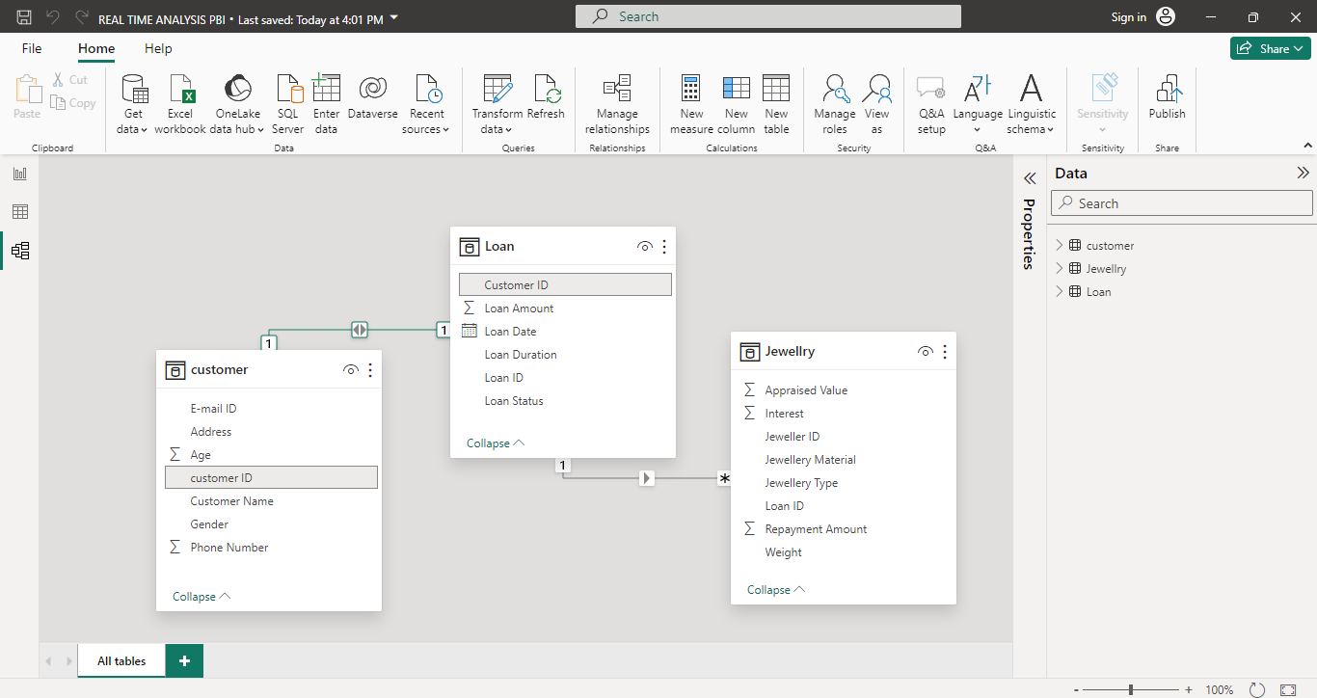

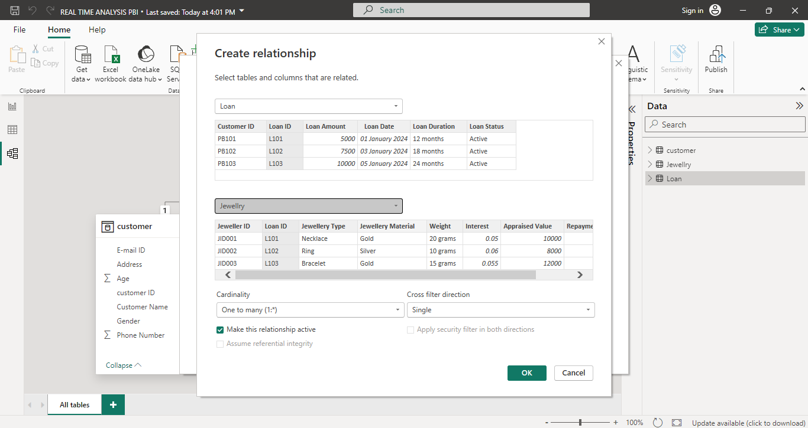**Edit Relationship**

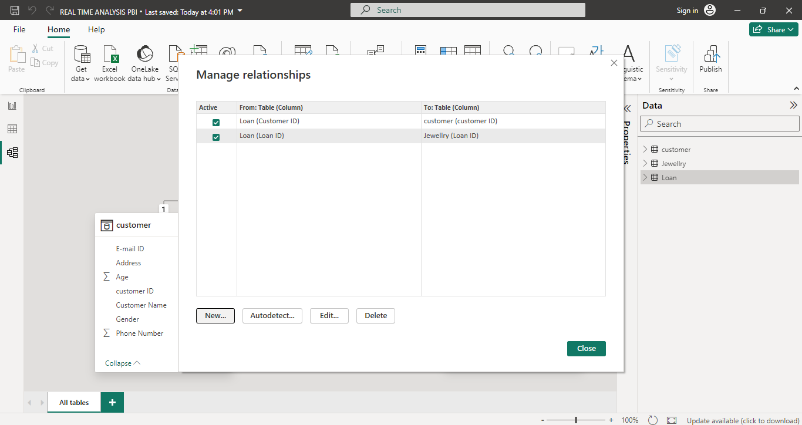

**Modelling data**

In this form analyze the distinct values and remove the duplicate values.

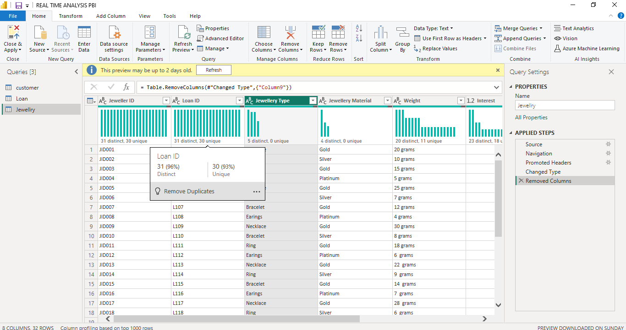

**CHANGE TYPE**

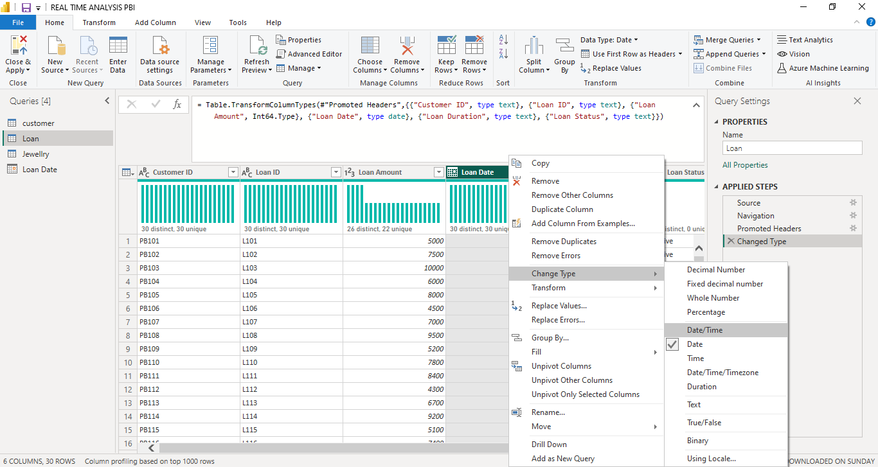In transforming data remove the null values and change the type of the data in a particular column .Here, in a loan date column has been changed date DD-MM-YYYY format.

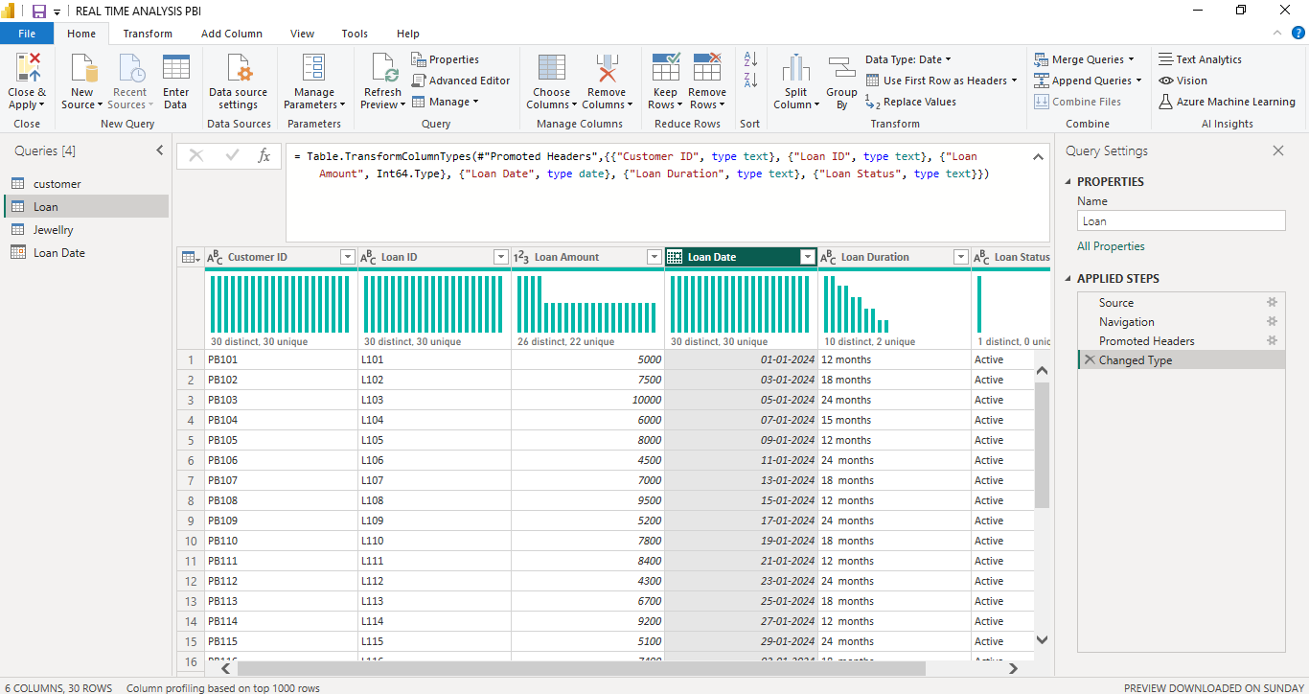

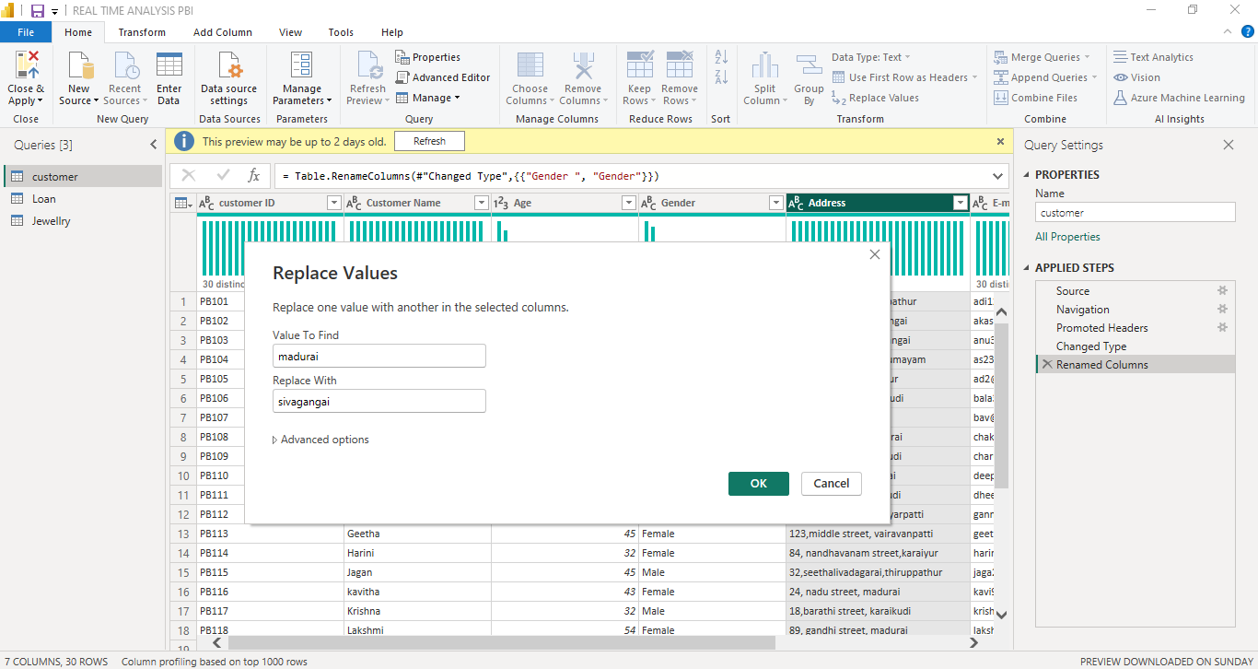**REPLACE VALUES**

In address field replace the city name to another with the Power Query Editor.

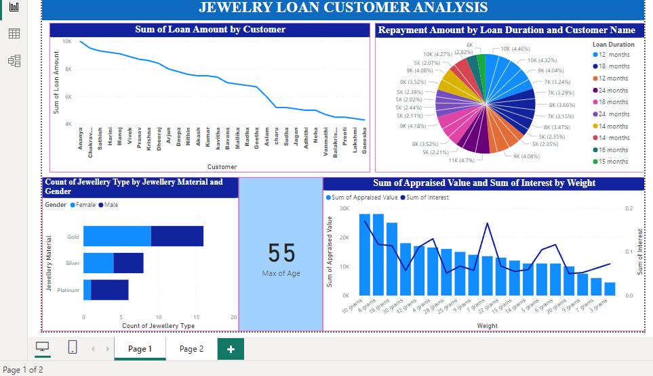**Dashboard**

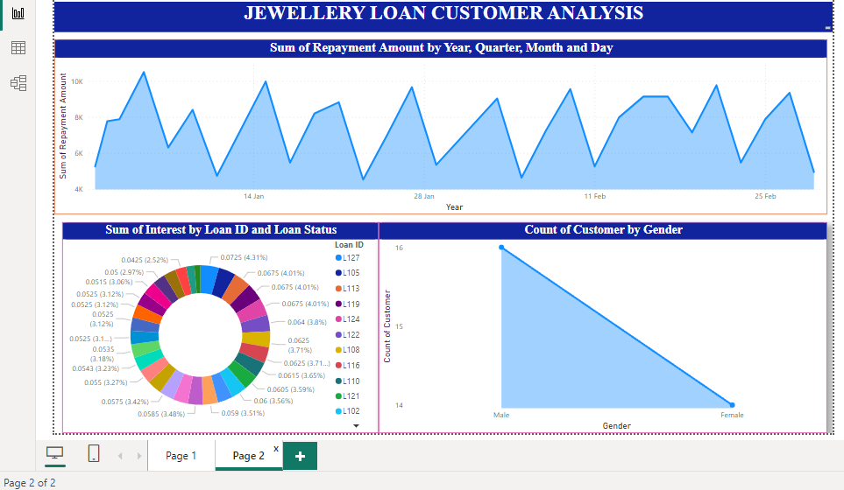

**CONCLUSION**

The project “**Real-Time Analysis of Jewelry Loan Bank Customers**” using Power BI has successfully demonstrated the potential of data analytics in the banking sector. Analyzing jewelry loan data can provide valuable insights into customer behavior, loan trends, and business performance. With Power BI, you can create interactive dashboards and reports that allow you to visualize key metrics such as loan amounts, interest rates, customer demographics, and loan repayment patterns. By leveraging real-time data analysis, you can make informed decisions to optimize loan offerings, improve customer satisfaction, and enhance overall business operations. The project has also highlighted the importance of data visualization in making complex data more understandable and accessible. The use of Power BI has made it possible to present data in a visually appealing and easy-to-understand format, thereby aiding in better decision-making.

**FUTURE SCOPE**

The future scope of the jewelry loan analysis project for banks can be quite broad and impactful. Power BI can be leveraged to predict future trends based on historical data. Integrating these predictive analytics into the project could enable the bank to anticipate customer needs and proactively offer solutions. Furthermore, Power BI’s capability to integrate with various data sources opens up the possibility of incorporating more diverse datasets for a more holistic view of customers. Utilize machine learning models to predict customer behavior, loan default probabilities, and optimal loan terms. This can help banks proactively manage risks and improve decision-making. Refine customer segmentation based on loan history, demographics, and transactional data to tailor loan products and marketing strategies for different customer groups. Implement advanced fraud detection algorithms to identify and prevent fraudulent loan applications, reducing financial losses for the bank. Analyze market trends and competitor offerings to identify opportunities for new loan products or enhancements to existing ones. In streamline loan processing and approval workflows through automation and process optimization, reducing turnaround times and improving customer satisfaction.

Enhance regulatory compliance by integrating regulatory reporting requirements into the analytics platform, ensuring adherence to industry standards and regulations. Integrate the loan analysis platform with other banking systems such as core banking, CRM, and loan servicing systems to provide a holistic view of customer relationships and loan lifecycle management. Develop mobile and online banking features that leverage loan analysis insights to provide customers with personalized loan management tools and real-time updates. Explore the use of blockchain technology and digital assets for secure and efficient loan transactions, enabling faster loan disbursements and settlements.

Overall, the future scope of the jewelry loan analysis project is vast, with opportunities to drive innovation, improve customer service, and enhance operational efficiency for banks.

**REFERENCES**

<https://www.youtube.com/live/NNdnLEsbClg?si=8EPOnKdinoyiw4ym>

**LINK**

[**https://pandimeenal23.github.io/Power-BI/**](https://pandimeenal23.github.io/Power-BI/)